Detect a Cycle in a Linked List
In this article we will solve the most asked interview question: Detect a Cycle in a Linked List
Problem Statement: Given head, the head of a linked list, determine if the linked list has a cycle in it. There is a cycle in a linked list if there is some node in the list that can be reached again by continuously following the next pointer.
Return true if there is a cycle in the linked list. Otherwise, return false.
Examples:
Example 1:
Input:
Head = [1,2,3,4]
Output:
true
Explanation: Here, we can see that we can reach node at position 1 again by following the next pointer. Thus, we return true for this case.
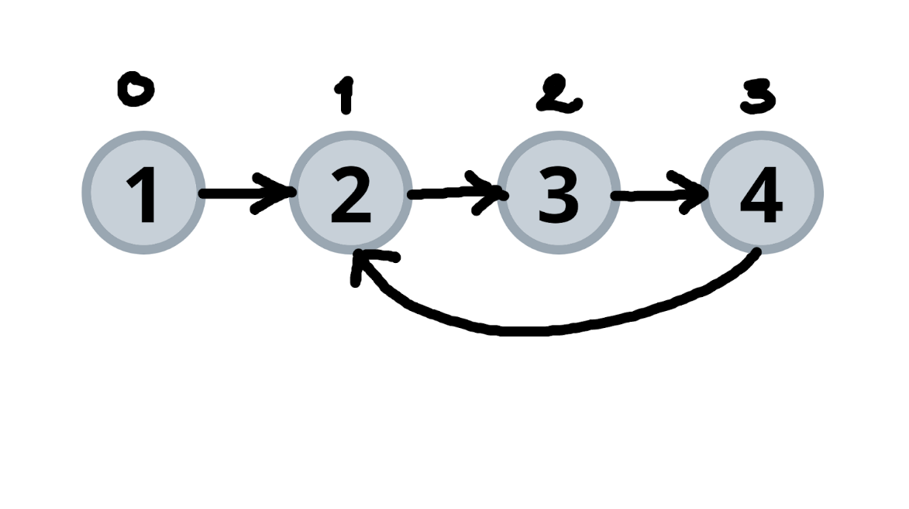
Example 2:
Input:
Head = [1,2,3,4]
Output:
false
Explanation: Neither of the nodes present in the given list can be visited again by following the next pointer. Hence, no loop exists. Thus, we return false.
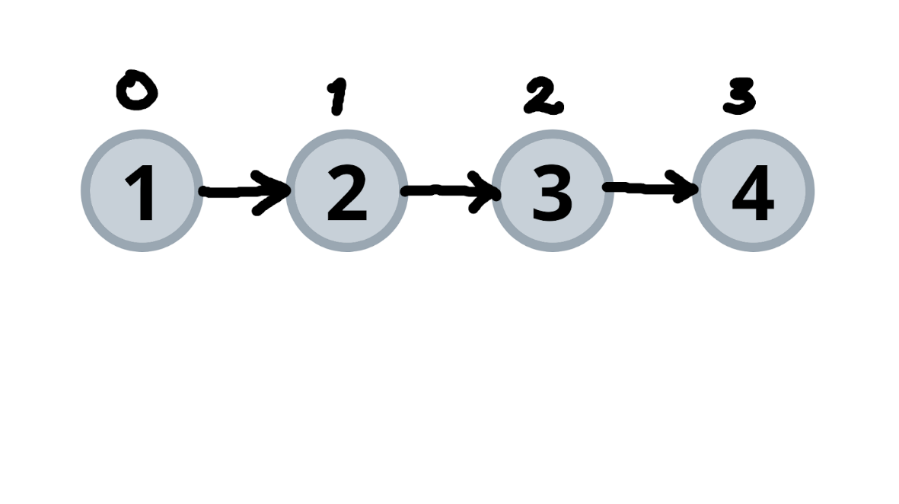
Solution: Hashing
Approach:
We need to keep track of all the nodes we have visited till now so that once we visit the same node again we can say that a cycle is detected. The process is as follows:
- Use a hash table for storing nodes.
- Start iterating through the lists.
- If the current node is present in the hash table already, this indicates the cycle is present in the linked list and returns true.
- Else move insert the node in the hash table and move ahead.
- If we reach the end of the list, which is NULL, then we can say that the given list does not have a cycle in it and hence we return false.
Dry Run:
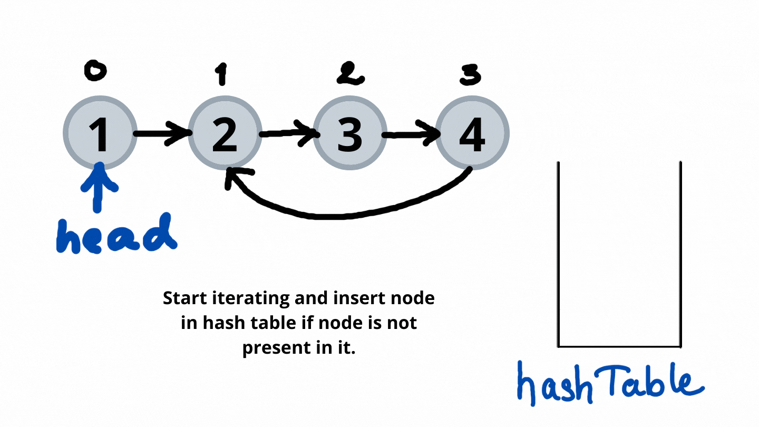
Code:
static boolean cycleDetect(Node head) {
HashSet <Node> hashTable=new HashSet<>();
while(head != null) {
if(hashTable.contains(head)) return true;
hashTable.add(head);
head = head.next;
}
return false;
}
Time Complexity: O(N)
Reason: Entire list is iterated once.
Space Complexity: O(N)
Reason: All nodes present in the list are stored in a hash table.
Solution: Slow and Faster Pointer
Approach:
We will use two pointers with different steps forward. The process is as follows:-
- We will take two pointers, namely fast and slow. Fast pointer takes 2 steps ahead and slow pointer takes 2 points ahead.
- Iterate through the list until the fast pointer is equal to NULL. This is because NULL indicates that there is no cycle present in the given list.
- Cycle can be detected when fast and slow pointers collide.
Dry Run:
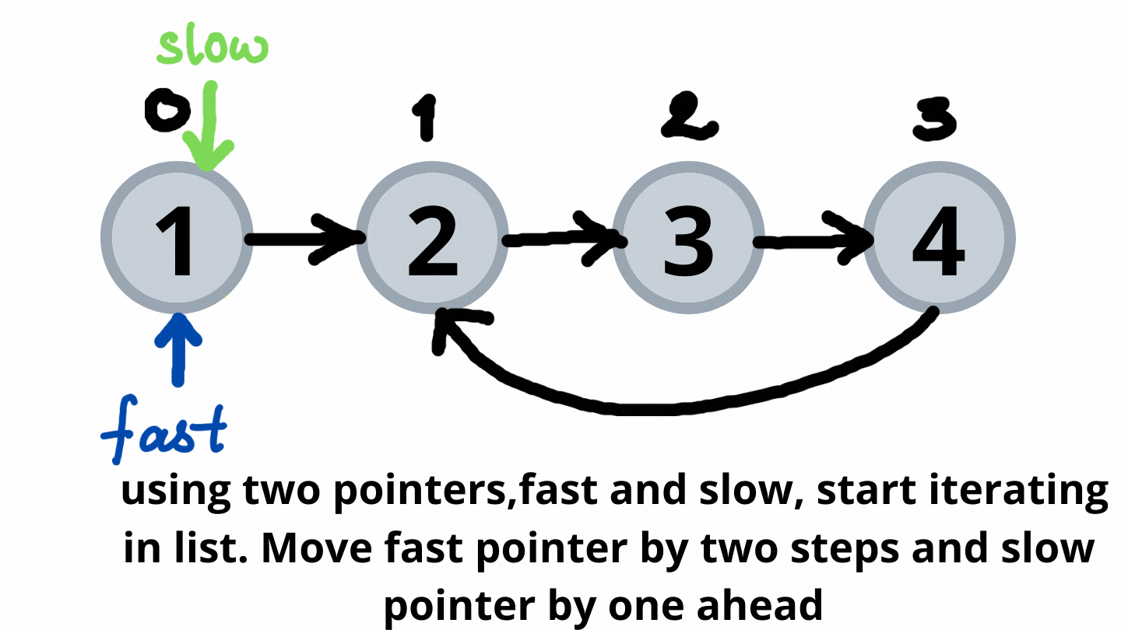
Code:
public boolean hasCycle(ListNode head) {
ListNode fast=head;
ListNode slow=head;
while(fast!=null&&fast.next!=null)
{
fast=fast.next.next;
slow=slow.next;
if(fast==slow)
return true;
}
return false;
}

